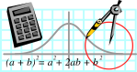  Rossmoyne SHS  Mathematics  Department | MATHEMATICS SPECIALIST 3CD | Semester 1 2010  EXAMINATION

NAME:
TEACHER: Mr Birrell Mr Whyte
Mr Longley

Section Two:
Calculator-assumed

Time allowed for this section
Reading time before commencing work: 10 minutes
Working time for this section: 100 minutes

Materials required/recommended for this section

To be provided by the supervisor
This Question/Answer Booklet
Formula Sheet (retained from Section One)

To be provided by the candidate
Standard items: pens, pencils, pencil sharpener, eraser, correction fluid, ruler, highlighters

Special items: drawing instruments, templates, notes on two unfolded sheets of A4 paper, and up to three calculators satisfying the conditions set by the Curriculum Council for this examination

Important note to candidates
No other items may be taken into the examination room. It is your responsibility to ensure that you do not have any unauthorised notes or other items of a non-personal nature in the examination room. If you have any unauthorised material with you, hand it to the supervisor before reading any further.
Structure of this paper

Section | Number of questions available | Number of questions to be answered | Suggested working time  (minutes) | Marks  available
Section One:  Calculator-free | 7 | 7 | 50 | 40
Section Two:  Calculator-assumed | 15 | 15 | 100 | 80
 |  |  |  | 120

Instructions to candidates

- The rules for the conduct of Western Australian external examinations are detailed in the Year 12 Information Handbook 2010. Sitting this examination implies that you agree to abide by these rules.

2. Answer the questions according to the following instructions.

Section Two: Write answers in this Question/Answer Booklet. All questions should be answered.
Show all your working clearly. Your working should be in sufficient detail to allow your answers to be checked readily and for marks to be awarded for reasoning. Incorrect answers given without supporting reasoning cannot be allocated any marks. For any question or part question worth more than two marks, valid working or justification is required to receive full marks. If you repeat an answer to any question, ensure that you cancel the answer you do not wish to have marked.
It is recommended that you do not use pencil except in diagrams.

3. You must be careful to confine your responses to the specific questions asked and to follow any instructions that are specific to a particular question.

- Spare pages are included at the end of this booklet. They can be used for planning your responses and/or as additional space if required to continue an answer.
  - Planning: If you use the spare pages for planning, indicate this clearly at the top of the page.
  - Continuing an answer: If you need to use the space to continue an answer, indicate in the original answer space where the answer is continued, i.e. give the page number. Fill in the number of the question(s) that you are continuing to answer at the top of the page.
QUESTION | MARKS AVAILABLE | STUDENT MARK
1 | 3
2 | 3
3 | 5
4 | 4
5 | 4
6 | 3
7 | 6
8 | 4
9 | 5
10 | 5
11 | 3
12 | 6
13 | 7
14 | 10
15 | 12
TOTAL | 80

- 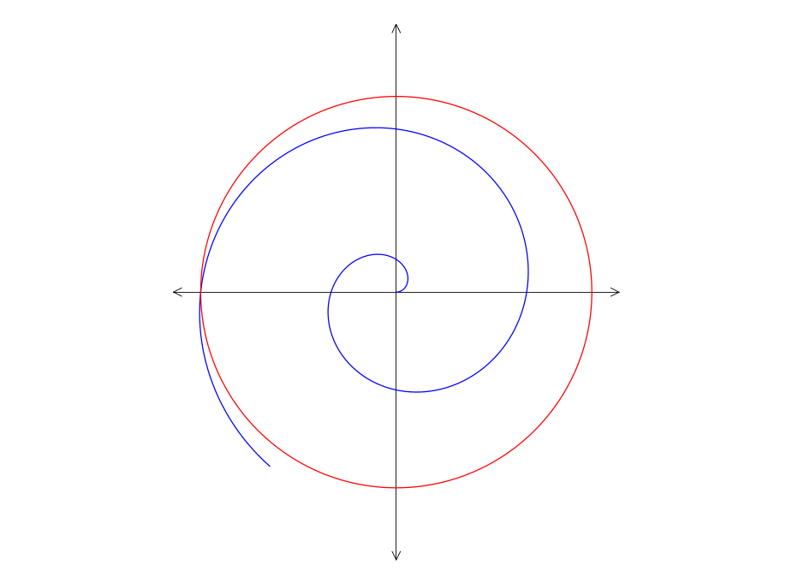[3 marks]
Consider the polar graphs of a spiral and a circle on the right.
If the Cartesian equation of the circle is 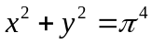
determine the polar equations of the spiral.
- [3 marks]
Points A, B and C have position vectors 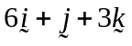, 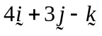 and 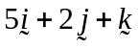 respectively. Prove that A, B and C are collinear.
- [3,2 marks]
A curve is defined by the parametric equations: 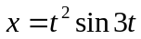 and 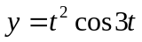
  - Find 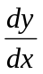 in terms of t.

  - Show that if the curve defined by these parametric equations is horizontal at any point, then 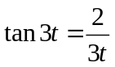.
- [4 marks]
Given 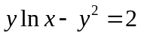 prove 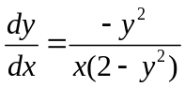.
- [4 marks]
Prove: 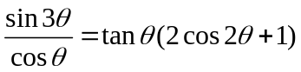

- [3 marks]
Find the acute angle that the vector 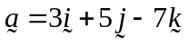 makes with the z-axis.

- [1,1,2,2 marks]
For 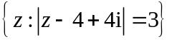 determine
  - The minimum possible value of Im(z)
  - The maximum possible value of 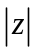
  - The minimum possible value of arg(z)
  - The cartesian equation of the curve.

- [4 marks]
Differentiate 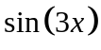 from first principals
- [5 marks]
Prove, by contradiction, that 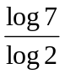 is irrational.
- [2,3 marks]
Represent the following on an Argand diagram.
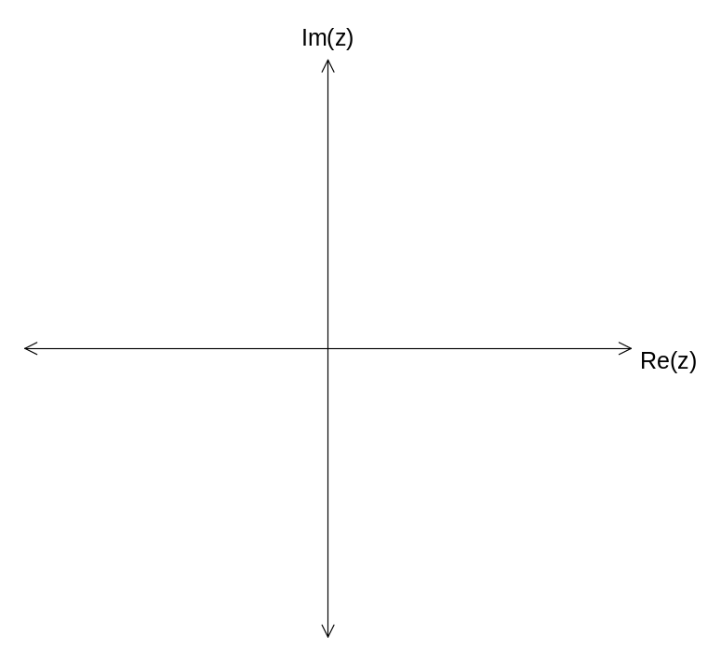
  - 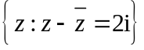
  - 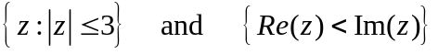
- [3 marks]
Points M and N have position vectors 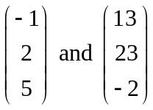 respectively. Find the position vector of the point that divides MN internally in the ratio 2:5.
- [6 marks]
Determine the shortest distance between the point P with position vector 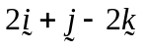 and the plane 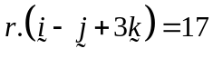.
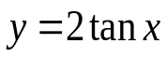
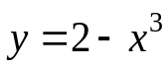
- 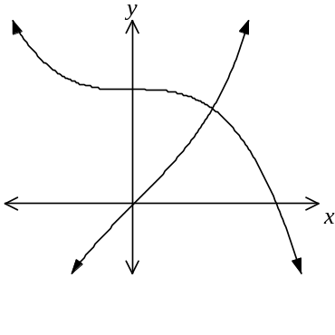[5,2 marks]
Let A and B be the regions in the first quadrant shown in the figure above. The region A is bounded by the y-axis and the graphs 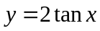 and 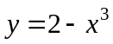. The region B is bounded by the x-axis and the graphs of and .
A
B
  - Find the area of region B accurate to 3 decimal places.
  - Find the area of region A accurate to 3 decimal places.

- [1,2,3,4 marks]
A fighter jet is maintaining a constant velocity of 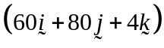 m/s, with the unit vectors representing directions East, North and Upwards respectively. Sea level is zero altitude. The fighter jet is being tracked from a mountain base 1250m above sea level. At 10 pm the jet is 35km West and 60km South of the base and its altitude is 2250m above sea level.
  - Find the position vector of the jet with respect to the base at 10.10 pm.
  - At what time is the jet due East of the base?
  - How far is the jet from the base at 10.15pm?
  - Find the least distance between the jet and the base.

- [5,5,2 marks]
The shape shown below consists of a trapezium with a semi-circle on top. The three straight edges are of fixed length k metres and the angle the two straight sides make with the vertical is 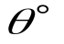 where 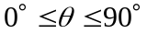.
k
k
k
  - Show that the area, A, of the shape is given by: 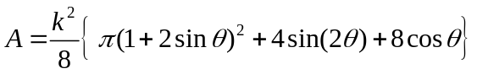
  - Using calculus, show that the area is optimised if 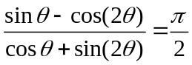
  - Determine the value of that maximises the area.

Additional working space

Question number(s):

Additional working space

Question number(s):

Additional working space

Question number(s):

Additional working space

Question number(s):

